1. 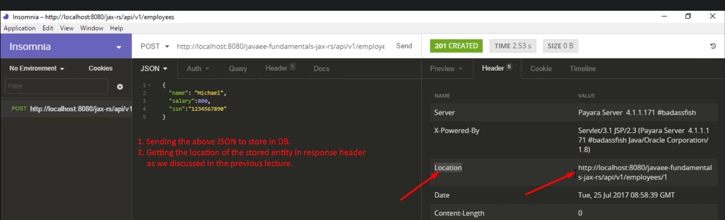  
   The above location’s value can be used to retrieve the saved entity.